**Publish profile transformation files:**

**Scenario:**

**Based on the deployment environment, need to copy the environment specific index/home page into Publish folder.**

**Sample scenario:**

**Deployment environment: server 34**

**Index page name: Index.Env34.html**

Step 1: Add the following line in root web.config file

*<system.webServer>*

*<defaultDocument enabled="true">*

*<files>*

*<clear/>*

*</files>*

*</defaultDocument>*

*</system.webServer>*

Step 2: Create an environment specific index page in the root path.

For example: Create Index.Env34.html and add this in the root path of API project.

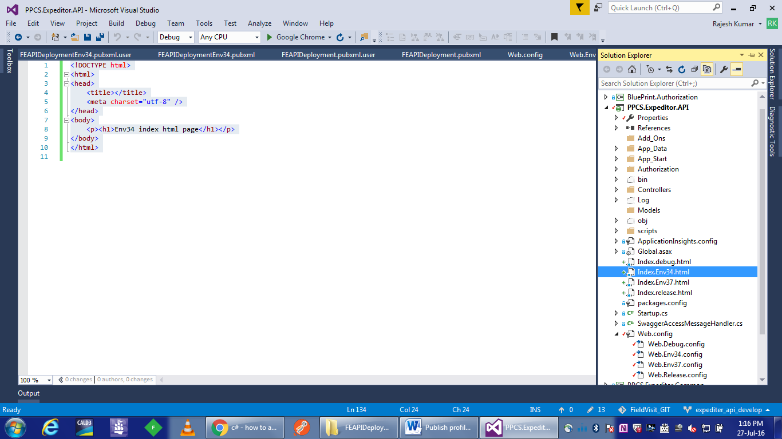

Step 3: In the specific transform web.config file, add the following line,

Transform file name: Web.config 🡪 web.Env34.config

*<system.webServer>*

*<defaultDocument enabled="true" xdt:Transform="Replace">*

*<files>*

*<clear/>*

*<add value="Index.Env34.html"/>*

*</files>*

*</defaultDocument>*

*</system.webServer>*

Step 4: Create a publish profile using Publish Web wizard as follows,

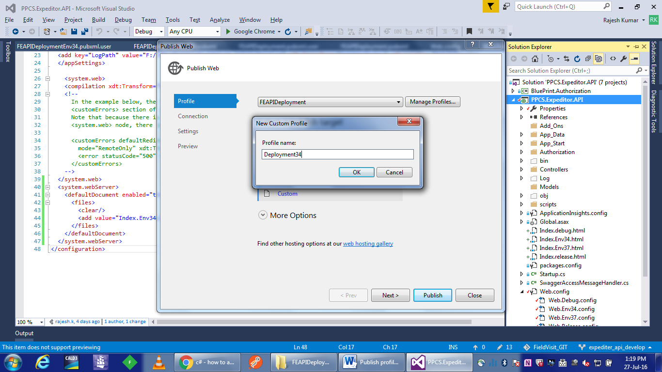

(By default, it will create a publish profile file under the API project properties)

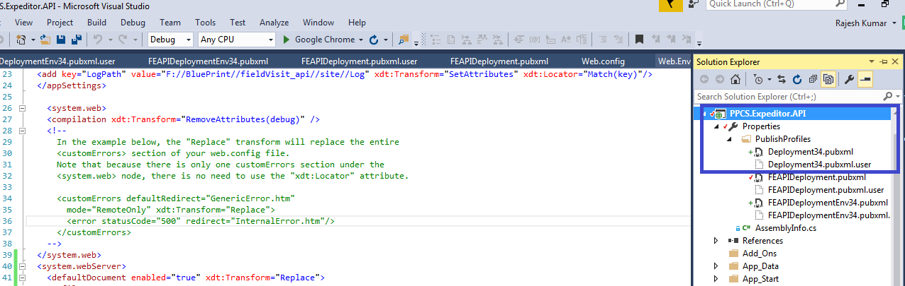

Step 4: Modify the Deployment34.pubxml file with the following lines,

*<PropertyGroup> <ExcludeFilesFromDeployment>Index.debug.html;Index.Env37.html;Index.Release.html</ExcludeFilesFromDeployment>*

*</PropertyGroup>*

**Index.debug.html; Index.Env37.html; Index.Release.html** – These files are created already under root *web.cofig* file for different deployment scenarios.

Step 5: Publish

Select the related data in profile and setting tabs.

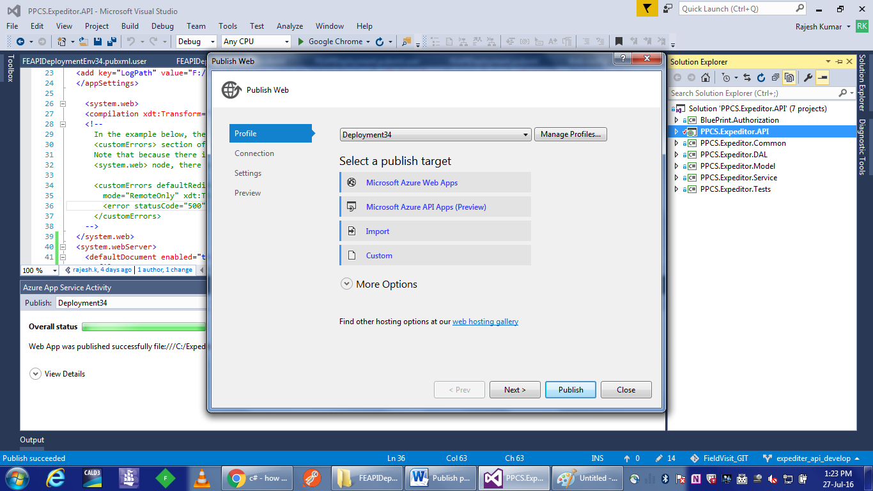

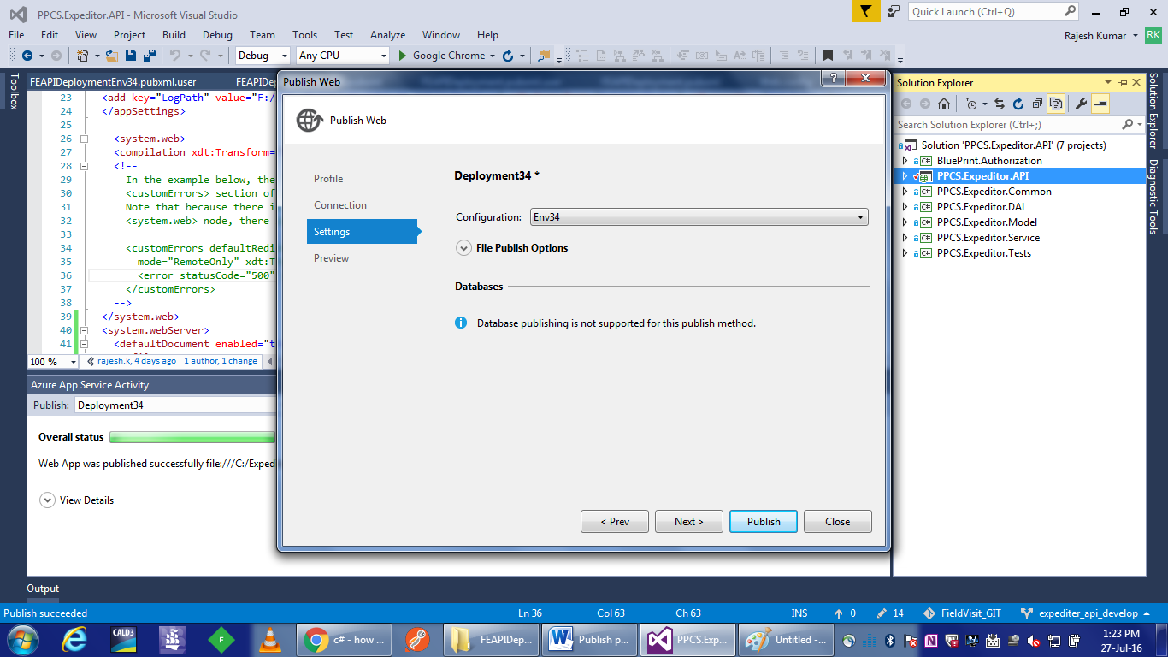

**In publish folder**, Index.Env34.html file copied. Note that not all files copied.

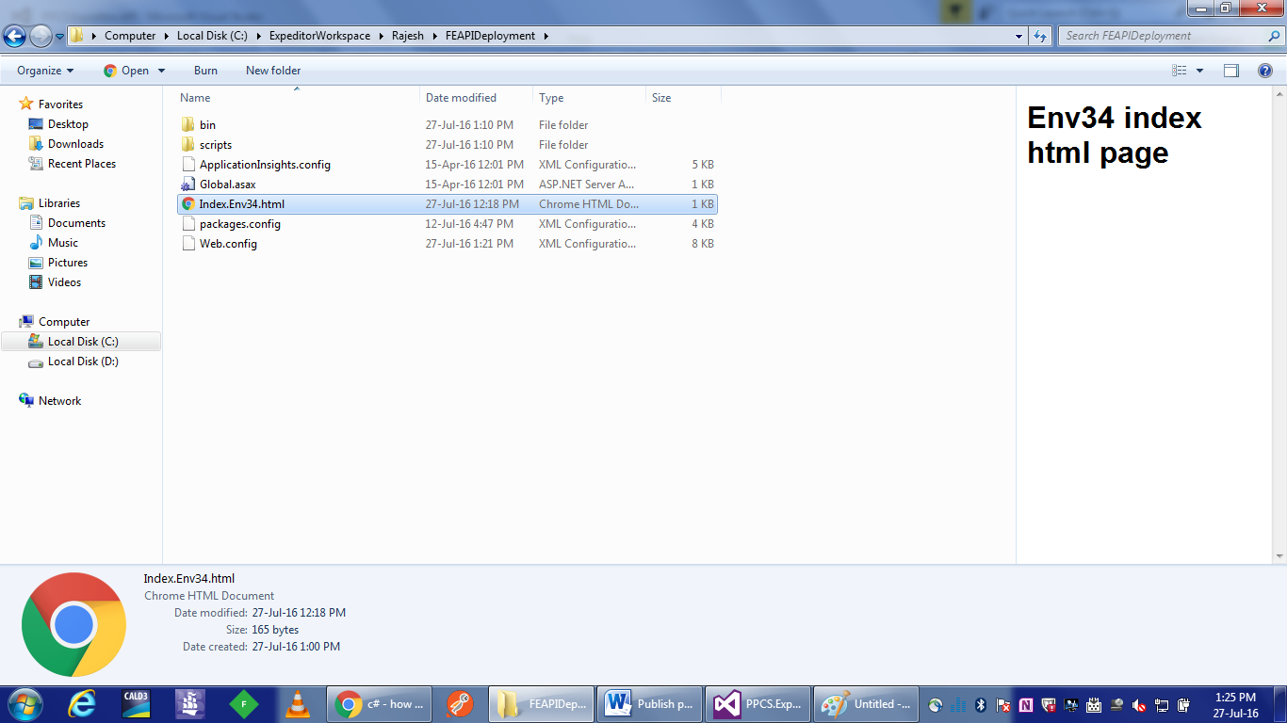

In the resultant *web.config* file is also updated with the environment specific index file.

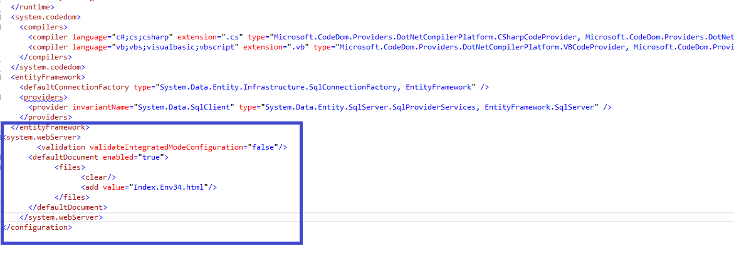

Great!!!